**WELCOME TO THE EV TRACKER BETA TEST**

Welcome to the EV Tracker beta test. You’ll be among the first users to use the new Android port of EV Tracker for iOS. These instructions will help you get your Beta copy.

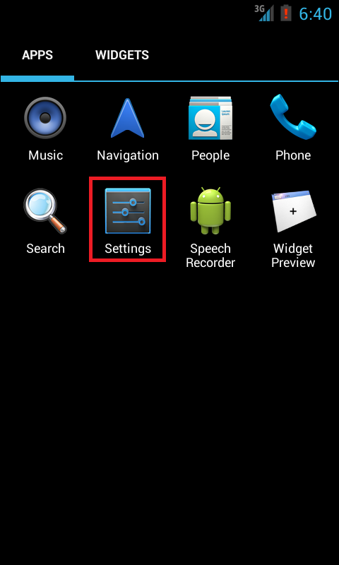

1. First you’ll need to enable your phone to install apps from unknown sources. Find your phone’s settings in the menu
2. 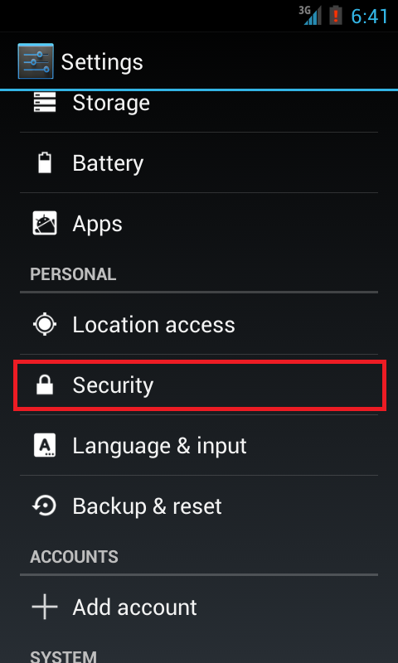Under Settings, select Security
3. 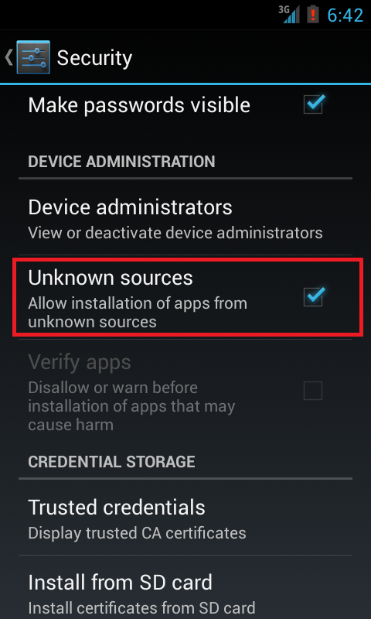Find Unknown sources under the Security menu and enable it.
4. Follow this link on your phone’s browser and install the downloaded file: <https://www.dropbox.com/s/tigfo7bvi8iruoe/EVTracker.apk>
5. Enjoy your beta test of EV Tracker for Android